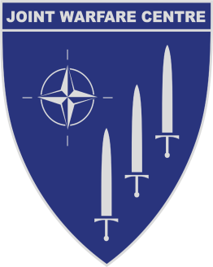
JOINT WARFARE CENTRE

Postbox 8080
N-4068 Stavanger, Norway
Telephone
Direct dial: 52879291/9290

Visiting address: Gamle Eikesetvei 29.

ON SITE ENGINEERING SUPPORT FOR NEC CCIS UPGRADE –
MAGNUM

PART III – SPECIAL PROVISIONS

SECTION A – CONTRACT MANAGEMENT DATA

IFIB-ACT-JWC-16-01

TABLE OF CONTENTS

1. EFFECTIVE DATE AND DURATION 2
2. REMUNERATION AND PRICES 2
3. POINTS OF CONTACTS 2

EFFECTIVE DATE AND DURATION

The duration of this Contract is from May-2016 (As soon as possible in May but not later than 30-May-16) to 31-December-2016 with possible three (3) extension-options. Notice of execution of the optional extension(s) will be provided in writing by the Contracting Officer no later than 60 (sixty) days before the contract expiration date.
This implies that the SUPPLIER is obligated to, but not entitled to, extension of the Contract on the terms and conditions stated herein.

REMUNERATION AND PRICES

All prices shall be in accordance with Part I Bidding Instruction Annex B Bid Form. All prices are in NOK and exclusive of Value Added Tax (VAT). The price is firm and fixed for the Contract.

POINTS OF CONTACTS

The SUPPLIER shall direct all inquiries, notices and communications regarding this Contract to the Contracting Officer, which may be personally delivered, mailed, or copied, to the following address:

Joint Warfare Centre,
Purchasing & Contracting Branch
P.O. Box 8080, 4068 Stavanger

The JWC POCs are:

Mr Kjetil Sand, Contracting Officer
Tel: +47 52 87 92 90
E-mail address: kjetil.sand@jwc.nato.int

CDR Paal Haarr, Contracting Officer
Tel: +47 52 87 92 91
E-mail address: paal.haarr@jwc.nato.int

All correspondence is to be forwarded to group email box: pcs@jwc.nato.int

The SUPPLIER’s POC is:
xxxxxxxxxxxxxxxxxxxxxx

