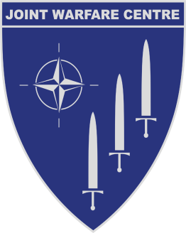

JOINT WARFARE CENTRE

Postbox 8080
N-4068 Stavanger, Norway

Date: 11 March 2016

Subject: Questions & Answers to IFIB-ACT-JWC-16-01

The following questions have been raised with respect to the subject IFIB. Response is to provide clarification;
# | Question | Response
001 | In order to provide a level playing field for all competitors we ask for JWC to consider to include a contractual clause providing a liability cap. We propose the clause used by the Norwegian Government's Standard Terms and Conditions for Consultancy Assistance:  No damages may be claimed in respect of indirect loss. Indirect loss includes, but is not limited to, lost earnings of any kind, lost savings, loss of data, and claims from third parties, with the exception of liability for damages imposed as a result of defects in title.  Overall damages over the term of the Agreement are limited to an amount that corresponds to the agreed consideration or an upper estimate for the Assistance, excluding Value Added Tax.  The said limitations shall not apply in the case of gross negligence or willful misconduct on the part of the defaulting party or anyone for whom it is responsible. | The Joint Warfare Centre has carefully considered the proposed change from both a financial and legal perspective and have concluded that the current wording of the general terms and conditions provide a balanced protection for both Joint Warfare Centre and the bidders/contractee. By inserting the proposed provision, JWC’s position may therefore be weakened.  Based on the above, JWC will not include this proposed provision into the terms.
002

